Version | Date | Who | Changes
.9 | 8/19/2024 | Gentry Martin | Initial request for this label. Layout all fields and logic that would be used on the label for clarity.
MEDSTD 4x6 Inner/Outer Production Label

MEDSTD 4x6 Inner/Outer – Outer Label
One outbox label is printed when the user selects to print this label from Workorders or Realtime within DelmiaWorks.
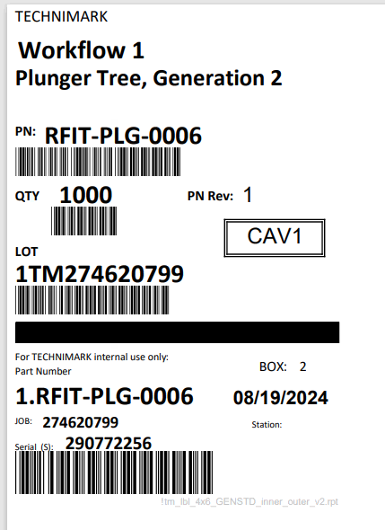
1. Hardcode Technimark Format
14
13
12
10
11
9
8
7
5
6
4
3
2
1
2. WorkFlow – Prompt while printing batch
3.Description - DelmiaWork Item description from inventory Item
4. Part and Barcode – Matched on ship to ID from sales order it is the AKA Selling Customer Item Number
5.Part Rev – Delmiawork Part Rev or if null then the AKA Selling customer part rev
6. Qty from position 1 in the bom for the outer box Quantity.
7. Cavity – the value pulled from the end of the MFG number. Logic is to look for CAV and then look at the end of string.
8. Lot Number – the logic for this is stored on the BOM with the Lot Prefix field added to the workorder number. Update by MRP.
9. Box – this is sequence of the BOX counter coming out of the printer.
10. Item Number – Technimark’s Inventory item number.
11.Label Date – the date in which the label was printed.
12. JOB – is the work order number from DelmiaWorks.
13. Station – the manufacturing machine that the label belong to for production
14.Serial Number – Unique sequence number that is used for moving, tracing and processing internal to Technimark

MEDSTD 4x6 Inner/Outer – Inner Label
Depending on the value of inner labels from the Additional Item Tab on the Inventory item; the system will produce that number of inner labels to go along with the outer box label.
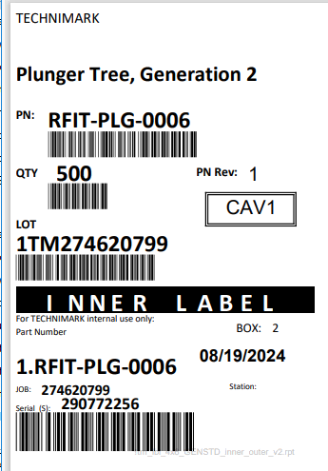
Called out Number are the difference from the outer box Label
1. The workflow question does not appear on the inner label. Request from the customer
3
2
1
2. Quantity – this is different than the outer label. This is calculated based off the outer label and then divided but the number of inner bags that are generated while printing.
3. Label – this is a call out for the floor to note that these labels are inner bags to an outer bag.

Other notes:
Box: this value is the same as the outer box so that there is a visual relationship between inner and outer labels.
Serial number – This is the exact same number that is on the outer box label. Again for traceability and matching.

